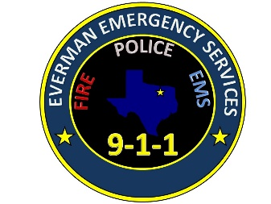
EVERMAN EMERGENCY SERVICES LWhatley@evermantx.net
404 W Enon Avenue (817) 293-6870
Everman, Texas 76140 (817) 293-0758(fax)
_________________________________________

WAIVER OF CLAIMS AND COVENANT NOT TO SUE
Date(s) to Ride In: _______________ Shift: __________________
In Consideration of The Permission Granted to Me by the City of Everman, Texas, to
accompany the Medic Crew of the City of Everman Fire Department, while on shift. I
___________________ Certify that I am at least 18 years of age, and that I hereby waive
(Print Name Here)
all claims for damage or loss to my person or property which may be caused directly or indirectly by an act or omission of the City of Everman, it’s Firefighters, Officers, Agents, or Employee’s. I assume the risk of all dangerous conditions or occurrences which may be encountered during said shift and waive any and all specific of the existence of such conditions or occurrences. I further release and discharge the City of Everman, it’s Firefighters, Officers, Agents, Servants, or Employee’s from any and all liability, claims, actions, whether real or asserted, of every nature, kind and do hereby covenant not to sue. I further certify that I have read the attached “Ride-Along” Standard Operating Procedure, which I do understand, and will comply with them as a condition for approval of this Ride-Along request.

Dated This__________ Day of____________ 202_________
Printed Name: ___________________________
Signature: ________________________________
To Be Completed by Ambulance Crew:

EMT/Medic Signature: ________________

ID#: __________Shift: __________

Everman Fire Department Medic 19
Approved: Denied:
Officer in Charge Name:
_______________________
Officer in Charge Signature:
_______________________
Assistant Chief/Director Signature:
___________________________

